**3a) Create a Servlet application to upload and download a file.**

~~~~~~~~~~~~~~~~~~~~~~~~~~~~~~~~~~**Upload a file** ~~~~~~~~~~~~~~~~~~~~~~~~~~~~~~~~~~~~~~~~~~

**File Name: Index.html**

<html>

<head>

<title>TODO supply a title</title>

<meta charset="UTF-8">

<meta name="viewport" content="width=device-width, initial-scale=1.0">

</head>

<body>

**<form action="FileUploadServlet" method="post" enctype="multipart/form-data">**

**Select File to Upload:<input type="file" name="file" id="file"> <br>**

**Destination <input type="text" value="" name="destination"> <br>**

**<input type="submit" value="Upload file" name="upload" id="upload">**

**</form>**

</body>

</html>

**File Name: FileUploadServlet.java**

package mypack;

**import java.io.*;**

**import javax.servlet.*;**

**import javax.servlet.annotation.MultipartConfig;**

**import javax.servlet.http.*;**

**@MultipartConfig**

public class FileUploadServlet extends HttpServlet {

@Override

protected void doPost(HttpServletRequest request, HttpServletResponse response)

throws ServletException, IOException {

**response.setContentType("text/html");**

**PrintWriter out = response.getWriter();**

**String path=request.getParameter("destination");**

**Part filePart=request.getPart("file");**

**String filename=filePart.getSubmittedFileName();**

**out.print("<br><br><hr> file name: "+filename);**

**OutputStream os=null;**

**InputStream is=null;**

**try {**

**os=new FileOutputStream(new File(path+File.separator+filename));**

**is=filePart.getInputStream();**

**int read=0;**

**while ((read = is.read()) != -1)**

**{**

**os.write(read);**

**}**

**out.println("<br>file uploaded sucessfully...!!!");**

**} catch (FileNotFoundException e) {**

**out.print(e);**

**}**

}

}

**Output:**

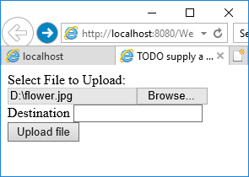 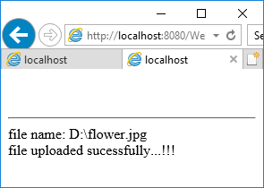

~~~~~~~~~~~~~~~~~~~~~~~~~~~~~~~~~~~~~~Download a file ~~~~~~~~~~~~~~~~~~~~~~~~~~~~~~~~~~~~

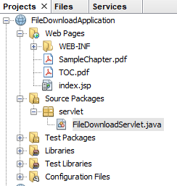

**File Name: index.jsp**

<%@page contentType="text/html" pageEncoding="UTF-8"%>

<!DOCTYPE html>

<html>

<head>

<meta http-equiv="Content-Type" content="text/html; charset=UTF-8">

<title>File Download Page</title>

</head>

**<body>**

**<h1>File Download Application</h1>**

**Click <a href="FileDownloadServlet?filename=SampleChapter.pdf">Sample Chapter</a>**

**<br/><br/>**

**Click <a href="FileDownloadServlet?filename=TOC.pdf">Table Of Contents</a>**

**</body>**

</html>

**File Name: FileDownloadServlet**

package servlet;

import java.io.*;

import javax.servlet.*;

import javax.servlet.http.*;

**@WebServlet(name = "FileDownloadServlet", urlPatterns = {"/FileDownloadServlet"})**

public class FileDownloadServlet extends HttpServlet {

@Override

protected void doGet(HttpServletRequest request, HttpServletResponse response) throws ServletException, IOException {

**String fileToDownload = request.getParameter("filename");**

**System.err.println("Downloading file now...");**

**downloadFile(request, response, fileToDownload);**

}

**private void downloadFile(HttpServletRequest request, HttpServletResponse response, String fileName) throws ServletException, IOException {**

**int lenght = 0;**

**try (ServletOutputStream outputStream = response.getOutputStream()) {**

**ServletContext context = getServletConfig().getServletContext();**

**response.setContentType((context.getMimeType(fileName) != null) ? context.getMimeType(fileName) : "application/pdf");**

**response.setHeader("Content-Disposition", "attachment; filename=\"" + fileName);**

**InputStream inputStream = context.getResourceAsStream("/" + fileName);**

**byte[] bytes = new byte[1024];**

**while((inputStream != null) && ((lenght = inputStream.read(bytes)) != -1)) {**

**outputStream.write(bytes, 0, lenght);**

**}**

**outputStream.flush();**

**}**

**}**

}

**Output:**

